OOP THEORY ASSIGNMENT 02 SUBMISSION
NAME: YASH RAJ
ROLL NUMBER: 24K-0737

QUESTION#1:
CODE:
#include<iostream>
#include<string>
#include<cstdlib>
using namespace std;

class user {
protected:
string name;
string id;
string department;
bool feespaid;
bool transportactivecard;
string ans;
string route;
string pickup;
string dropoff;

public:
user(string name, string id, string department) : name(name), id(id), department(department), feespaid(false), transportactivecard(false) {}

virtual void registerfortransport() {
string answer;
cout << "Do you want to register for transport (Yes/No)" << endl;
getline(cin, answer);
if (answer == "yes") {
checkfees();
} else {
cout << "Exiting the program" << endl;
exit(0);
}
}

virtual void checkfees() {
cout << name << " have you paid your semester fees?" << endl;
cin >> ans;
cin.ignore();
if (ans == "yes") {
feespaid = true;
activatetransportcard();
booktransport();
} else {
cout << "Sorry! " << name << " to book your transport you must pay your semester fees" << endl;
exit(0);
}
}

virtual void booktransport() {
cout << "Enter your route:" << endl;
cout << "1.Clifton" << endl;
cout << "2.Tariq Road" << endl;
cout << "3.North Nazimabad" << endl;
cout << "4.Shahra-e-Faisal" << endl;
getline(cin, route);
cout << "Enter your pickup point:" << endl;
getline(cin, pickup);
cout << "Enter your drop off point:" << endl;
getline(cin, dropoff);
cout << "You have successfully booked your transport for " << route << " route" << endl;
}

virtual void activatetransportcard() {
if (feespaid) {
transportactivecard = true;
cout << name << " your transport card has been activated! Book your transport:" << endl;
}
}

virtual void displaydetails() {
cout << "====User Details====" << endl;
cout << "Name: " << name << endl;
cout << "Id: " << id << endl;
cout << "Department: " << department << endl;
cout << "Fees paid (Yes/No): " << ans << endl;
cout << "Route: " << route << endl;
cout << "Pickup point: " << pickup << endl;
cout << "Drop off point: " << dropoff << endl;
}

string getroute() {
return route;
}
string getname() {
return name;
}
string getid() {
return id;
}

bool operator ==(const user &other) const{
return route == other.route;
}
};

class student : public user {
public:
student(string name, string id, string department) : user(name, id, department) {}

void registerfortransport() override {
user::registerfortransport();
}

void checkfees() override {
user::checkfees();
}

void booktransport() override {
user::booktransport();
}

void activatetransportcard() override {
user::activatetransportcard();
}

void displaydetails() override {
cout << "====Student Details====" << endl;
cout << "Student Name: " << name << endl;
cout << "Id: " << id << endl;
cout << "Department: " << department << endl;
cout << "Fees paid (Yes/No): " << ans << endl;
cout << "Route: " << route << endl;
cout << "Pickup point: " << pickup << endl;
cout << "Drop off point: " << dropoff << endl;
}
};

class Teacher: public user{
public:
Teacher(string name, string id, string department) : user(name, id, department) {}

void registerfortransport() override {
user::registerfortransport();
}

void checkfees() override {
cout << name << " have you paid your monthly fees?" << endl;
cin >> ans;
cin.ignore();
if (ans == "yes") {
feespaid = true;
activatetransportcard();
booktransport();
} else {
cout << "Sorry! " << name << " to book your transport you must pay your monthly fees" << endl;
exit(0);
}
}

void booktransport() override {
user::booktransport();
}

void activatetransportcard() override {
user::activatetransportcard();
}

void displaydetails() override {
cout << "====Teacher Details====" << endl;
cout << "Teacher Name: " << name << endl;
cout << "Id: " << id << endl;
cout << "Department: " << department << endl;
cout << "Fees paid (Yes/No): " << ans << endl;
cout << "Route: " << route << endl;
cout << "Pickup point: " << pickup << endl;
cout << "Drop off point: " << dropoff << endl;
}
};

class staff : public user{
public:
staff(string name, string id, string department) : user(name, id, department) {}

void registerfortransport() override {
user::registerfortransport();
}

void checkfees() override {
cout << name << " have you paid your monthly fees?" << endl;
cin >> ans;
cin.ignore();
if (ans == "yes") {
feespaid = true;
activatetransportcard();
booktransport();
} else {
cout << "Sorry! " << name << " to book your transport you must pay your monthly fees" << endl;
exit(0);
}
}

void booktransport() override {
user::booktransport();
}

void activatetransportcard() override {
user::activatetransportcard();
}

void displaydetails() override {
cout << "====Staff Details====" << endl;
cout << "Staff Name: " << name << endl;
cout << "Id: " << id << endl;
cout << "Department: " << department << endl;
cout << "Fees paid (Yes/No): " << ans << endl;
cout << "Route: " << route << endl;
cout << "Pickup point: " << pickup << endl;
cout << "Drop off point: " << dropoff << endl;
}

};

int main() {
cout << "Name: Yash Raj" << endl;
cout << "Roll Number: 24k-0737" << endl;

student s1("Yash Raj", "24k-0737", "cs");
s1.registerfortransport();
s1.displaydetails();

Teacher T("sir Rahim","TK-001","physics");
T.registerfortransport();
T.displaydetails();

staff Sf("Akbar","101-99","Gardening");
Sf.registerfortransport();
Sf.displaydetails();

if(s1==T && T==Sf){
cout<<"All users have same route"<<endl;
}
else{
cout<<"All users have different routes"<<endl;
}

}

UML DIAGRAM:
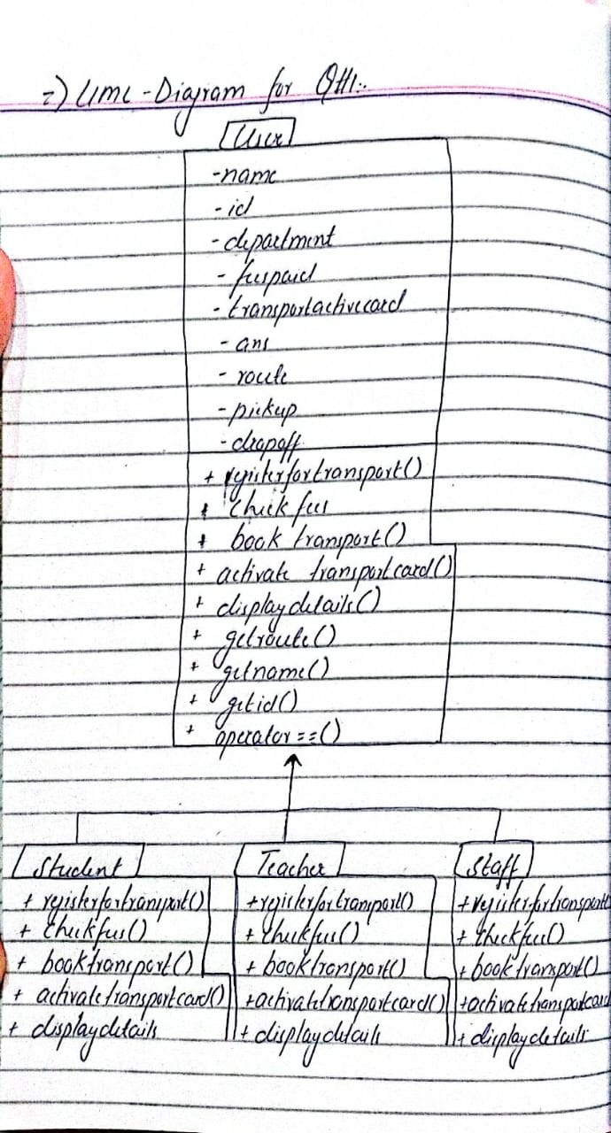

OUTPUT:
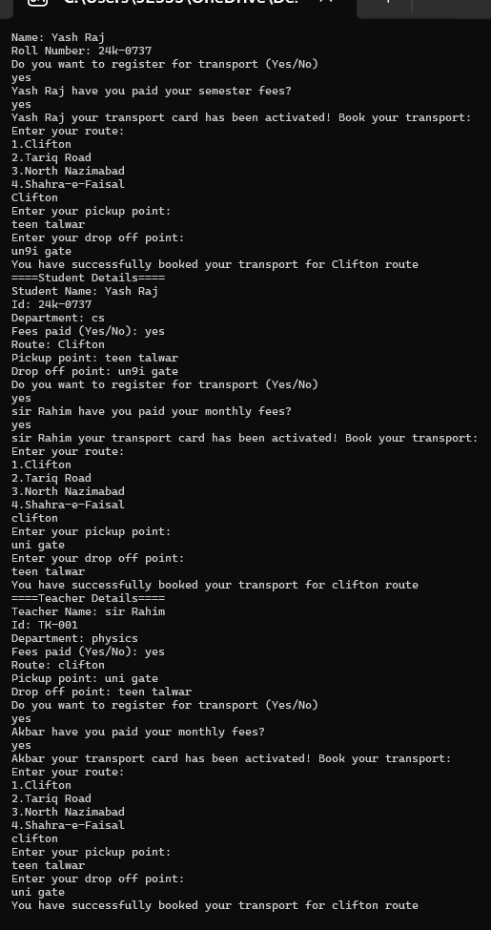

Question#2:
CODE:
#include <iostream>
using namespace std;
class ghosts {
public:
string name;
int scareLevel;
public:
ghosts(){};
ghosts(string name, int scareLevel):name(name),scareLevel(scareLevel){}
virtual void performHaunting(){
cout<<"SPOOOOOOOKKKKYYYYY !"<<endl;
}
int getscareLevel(){
return scareLevel;
}
friend ostream &operator<<(ostream &out,const ghosts &obj){
out<<obj.name<<endl;
out<<obj.scareLevel<<endl;
return out;
}
ghosts operator+(ghosts const &obj){
ghosts biggerGhost;
biggerGhost.name=name+obj.name;
biggerGhost.scareLevel=scareLevel+obj.scareLevel;
return biggerGhost;
}
};

class poltergeist : virtual public ghosts {
public:
poltergeist(string name, int scareLevel) : ghosts(name, scareLevel) {}
void performHaunting() {
cout << "GGGRRRRRRR BAANNGG !" << endl;
}
};

class banshee : virtual public ghosts {
public:
banshee(string name, int scareLevel) : ghosts(name, scareLevel) {}
void performHaunting() {
cout << "OOOOOOOHHHHHHHH AAAAAAHHHHHH !" << endl;
}
};

class shadowGhost : virtual public ghosts {
public:
shadowGhost(string name, int scareLevel) : ghosts(name, scareLevel) {}
void performHaunting() {
cout << "EEEEHHHEHEHEHEHEHEHE !" << endl;
}
};

class shadowPoltergeist : public shadowGhost, public poltergeist {
public:
shadowPoltergeist(string name, int scareLevel)
: ghosts(name, scareLevel), shadowGhost(name, scareLevel), poltergeist(name, scareLevel) {}

void performHaunting() {
shadowGhost::performHaunting();
poltergeist::performHaunting();
}
};

class visitor {
public:
string name;
int bravery;

visitor(string name, int bravery) : name(name), bravery(bravery) {}

void visitorReact(int scareLevel)const {
if (bravery < scareLevel) {
cout << name << ": AAAAHHHH Run!" << endl;
} else if (bravery > scareLevel) {
cout << name << ": HAHAHAHA Look at that so-called GHOOOOST!" << endl;
} else {
cout << name << ": GGGGGHHHHHOOOOSSSSTTT!" << endl;
}
}
};

class hauntedHouse {
string name;
ghosts *g[10];
int ghostCount;

public:
hauntedHouse(string name) : name(name), ghostCount(0) {}
~hauntedHouse(){
for (int i = 0; i < ghostCount; ++i)
delete g[i];
}
void addGhost(ghosts *gho){
if (ghostCount < 10){
g[ghostCount++] = gho;
}
}
friend void visit(const visitor v[], int visitorCount, const hauntedHouse &house);
};

void visit(const visitor v[], int visitorCount, const hauntedHouse &house) {
cout << "Visitors Entering the House: " << house.name << endl;
for (int i = 0; i < house.ghostCount; i++) {
house.g[i]->performHaunting();
for (int j = 0; j < visitorCount; j++) {
v[j].visitorReact(house.g[i]->getscareLevel());
}
}
}

int main() {
cout<<"Name : Yash Raj having Roll Number: 24k-0737 have done this assignment"<<endl;
hauntedHouse house1("Spooky Manor");
house1.addGhost(new poltergeist("Yash", 7));
house1.addGhost(new banshee("Saad", 5));
house1.addGhost(new shadowGhost("Mubashir", 6));
hauntedHouse house2("Dark Hollow");
house2.addGhost(new shadowPoltergeist("Rehman", 8));
house2.addGhost(new banshee("Sagar", 6));
visitor v[4] = {{"Akash", 4}, {"Akshay", 7}, {"Aadu", 5}, {"Vivek", 3}};
visit(v, 4, house1);
visit(v, 4, house2);
return 0;
}

OUTPUT:
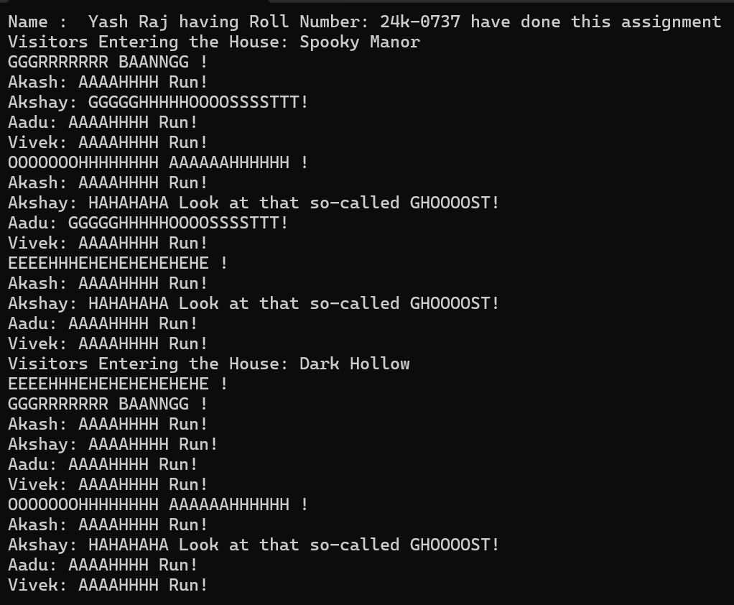

Question#3:
CODE:
#include<iostream>
using namespace std;
class vehicle{
protected:

int vehicleid;
static int totaldeliveries;
int speed;
public:

vehicle(int vehicleid,int speed){
this->vehicleid=vehicleid;
this->speed=speed;
totaldeliveries++;
}
virtual void calculateroute(const string& route){

cout<<"Selected Route: "<<route<<endl;
}

static int gettotaldeliveries(){
return totaldeliveries;
}

int getspeed(){
return speed;
}
int getvehicleid(){
return vehicleid;
}

friend bool compareSpeeds(const vehicle& v1, const vehicle& v2, const vehicle& v3) {
return (v1.speed == v2.speed) && (v2.speed == v3.speed);
}

virtual void calculatedeliverytime(const string& route){
cout<<"------Calculating Delivery Time------"<<endl;
if(route=="Clifton"){
cout<<vehicleid<<" Vehicle Delivering Time is approximately 15 minutes for route : "<<route<<endl;
}
else if(route=="North Nazimabad"){
cout<<vehicleid<<" Vehicle Delivering Time is approximately 30 minutes for route : "<<route<<endl;
}
else if(route=="Gulshan-e-Iqbal"){
cout<<vehicleid<<" Vehicle Delivering Time is approximately 45 minutes for route : "<<route<<endl;
}
else if(route=="Quaidabad"){
cout<<vehicleid<<" Vehicle Delivering Time is approximately 1 hour minutes for route : "<<route<<endl;
}
else{
cout<<"Invalid Route Selected"<<endl;
}
}
virtual void command(const string &command,const string& packageid,const string& urgency)=0;

};
int vehicle ::totaldeliveries = 0;

class RamzanTimeShip : public vehicle{
public:
RamzanTimeShip(int vehicleid,int speed):vehicle(vehicleid,speed){
}

void calculateroute(const string& route) override{
cout<<"Yash Raj(24k-0737)"<<endl;
cout<<"Selected Route: "<<route<<endl;
cout<<"Ramzan Time Ship is verifying historical consistency before transport for route: "<<route<<endl;
}
void calculatedeliverytime(const string& route) override{
cout<<"------Calculating Delivery Time------"<<endl;
if(route=="Clifton"){
cout<<vehicleid<<" Vehicle Delivering Time is approximately 15 minutes for route : "<<route<<endl;
}
else if(route=="North Nazimabad"){
cout<<vehicleid<<" Vehicle Delivering Time is approximately 30 minutes for route : "<<route<<endl;
}
else if(route=="Gulshan-e-Iqbal"){
cout<<vehicleid<<" Vehicle Delivering Time is approximately 45 minutes for route : "<<route<<endl;
}
else if(route=="Quaidabad"){
cout<<vehicleid<<" Vehicle Delivering Time is approximately 1 hour minutes for route : "<<route<<endl;
}
else{
cout<<"Invalid Route Selected"<<endl;
}
}

void command(const string &command,const string& packageid,const string&urgency)override{
cout<<"Command For Ramzan Time Ship: "<<command<<"- Package Id: "<<packageid<<" Urgency: "<<urgency<<endl;
if(urgency=="Urgent"){
cout<<"This Package is historically sensitive and requires validation !"<<endl;
}
}

};

class RamzanDrone: public vehicle{
public:
RamzanDrone(int vehicleid,int speed):vehicle(vehicleid,speed){
}

void calculateroute(const string& route) override{
cout<<"Selected Route: "<<route<<endl;
cout<<"Ramzan Drone is calculating an aerial route for high speed delivery for route: "<<route<<endl;
}
void calculatedeliverytime(const string& route) override{
cout<<"------Calculating Delivery Time------"<<endl;
if(route=="Clifton"){
cout<<vehicleid<<" Vehicle Delivering Time is approximately 15 minutes for route : "<<route<<endl;
}
else if(route=="North Nazimabad"){
cout<<vehicleid<<" Vehicle Delivering Time is approximately 30 minutes for route : "<<route<<endl;
}
else if(route=="Gulshan-e-Iqbal"){
cout<<vehicleid<<" Vehicle Delivering Time is approximately 45 minutes for route : "<<route<<endl;
}
else if(route=="Quaidabad"){
cout<<vehicleid<<" Vehicle Delivering Time is approximately 1 hour minutes for route : "<<route<<endl;
}
else{
cout<<"Invalid Route Selected"<<endl;
}
}

void command(const string &command,const string& packageid,const string&urgency)override{
cout<<"Command For Ramzan Drone: "<<command<<"- Package Id: "<<packageid<<" Urgency: "<<urgency<<endl;
if(urgency=="Urgent"){
cout<<"Activating High Speed mode to ensure an iftar meal arrives on time"<<endl;
}
}

};

class RamzanHyperpod : public vehicle{
public:
RamzanHyperpod(int vehicleid,int speed):vehicle(vehicleid,speed){
}

void calculateroute(const string& route) override{
cout<<"Selected Route: "<<route<<endl;
cout<<"Ramzan Hyperpod is calculating an undrground route to carry bulk package for route: "<<route<<endl;
}
void calculatedeliverytime(const string& route) override{
cout<<"------Calculating Delivery Time------"<<endl;
if(route=="Clifton"){
cout<<vehicleid<<" Vehicle Delivering Time is approximately 15 minutes for route : "<<route<<endl;
}
else if(route=="North Nazimabad"){
cout<<vehicleid<<" Vehicle Delivering Time is approximately 30 minutes for route : "<<route<<endl;
}
else if(route=="Gulshan-e-Iqbal"){
cout<<vehicleid<<" Vehicle Delivering Time is approximately 45 minutes for route : "<<route<<endl;
}
else if(route=="Quaidabad"){
cout<<vehicleid<<" Vehicle Delivering Time is approximately 1 hour minutes for route : "<<route<<endl;
}
else{
cout<<"Invalid Route Selected"<<endl;
}
}

void command(const string &command,const string& packageid,const string&urgency)override{
cout<<"No command is required for Ramzan Hyperpod"<<endl;
}
};

void ResolveConflict(vehicle &v1, vehicle &v2, vehicle &v3) {
if (v1.getspeed() == v2.getspeed() && v2.getspeed() == v3.getspeed()) {
cout << "All three vehicles have the same efficiency, any can proceed with delivery." << endl;
} else if (v1.getspeed() >= v2.getspeed() && v1.getspeed() >= v3.getspeed()) {
cout << "Vehicle with ID: " << v1.getvehicleid() << " and speed: " << v1.getspeed() << " will proceed with the delivery" << endl;
} else if (v2.getspeed() >= v1.getspeed() && v2.getspeed() >= v3.getspeed()) {
cout << "Vehicle with ID: " << v2.getvehicleid() << " and speed: " << v2.getspeed() << " will proceed with the delivery" << endl;
} else {
cout << "Vehicle with ID: " << v3.getvehicleid() << " and speed: " << v3.getspeed() << " will proceed with the delivery" << endl;
}
}

int main(){
string route;
cout<<"Enter the Delivery route:-"<<endl;
cout<<"1. Clifton"<<endl;
cout<<"2. North Nazimabad"<<endl;
cout<<"3. Gulshan-e-Iqbal"<<endl;
cout<<"4. Quaidabad"<<endl;
cin>>route;

cout<<"====Ramzan Time Ship===="<<endl;
RamzanTimeShip T(223,12);
T.calculateroute(route);
T.calculatedeliverytime(route);
T.command("Deliver","24k-0737","Urgent");

cout<<"====Ramzan Drone===="<<endl;
RamzanDrone D(223,13);
D.calculateroute(route);
D.calculatedeliverytime(route);
D.command("Deliver","24k-0737","Urgent");

cout<<"====Ramzan Hyperpod===="<<endl;
RamzanHyperpod H(223,21);
H.calculateroute(route);
H.calculatedeliverytime(route);

cout<<"====Decision===="<<endl;
ResolveConflict(T,D,H);

cout<<"Total Deliveries: "<<vehicle::gettotaldeliveries()<<endl;
return 0;
}
OUTPUT:
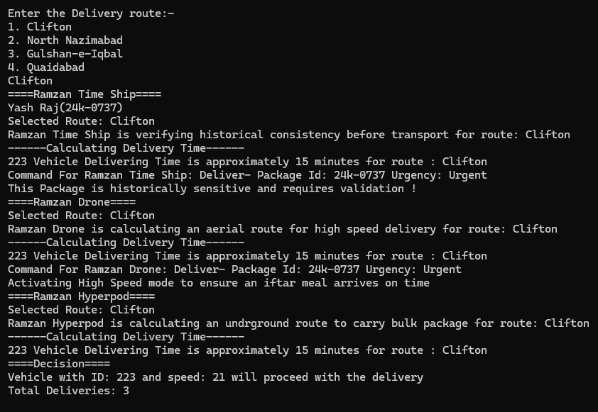

Question#4:
CODE:
//Yash Raj//
//24k-0737//
#include <iostream>
#include <string>
using namespace std;

double hashedPassword(string password) {
double hash = 5381;
for (int i = 0; i < password.length(); i++) {
hash = (hash * 33) + password[i];
}
return hash;
}

class user {
public:
string name;
int id;
string permissions[5];
string email;
double hashed_password;

user(string name, int id, string permissions[], string email, double hashed_password)
: name(name), id(id), email(email), hashed_password(hashed_password) {
for (int i = 0; i < 5; i++) {
this->permissions[i] = permissions[i];
}
}

virtual void display() {
cout << "Name: " << name << endl;
cout << "ID: " << id << endl;
cout << "Permissions: ";
for (int i = 0; i < 5; i++) {
if (!permissions[i].empty()) cout << permissions[i] << " ";
}
cout << endl;
cout << "Email: " << email << endl;
}

bool hasPermission(string action) {
for (int i = 0; i < 5; i++) {
if (permissions[i] == action) {
return true;
}
}
return false;
}
};

void authenticateAndPerformAction(user* u, string action) {
if (u->hasPermission(action)) {
cout << u->name << " is authorized to perform " << action << endl;
}
else {
cout << u->name << " is NOT authorized to perform " << action << endl;
}
}

class student : public user {
public:
bool assignments[10];

student(string name, int id, string permissions[], string email, double hashed_password, bool assignments[])
: user(name, id, permissions, email, hashed_password) {
for (int i = 0; i < 10; i++) {
this->assignments[i] = assignments[i];
}
}

void submitAssignment(int n) {
if (n >= 0 && n < 10) {
assignments[n] = true;
cout << "Assignment " << n + 1 << " Submitted!" << endl;
}
else {
cout << "Invalid Assignment Number!" << endl;
}
}

void display() override {
cout << endl<<"Student Name: " << name << endl;
user::display();
}
};

class TA : public student {
public:
string students[10];
string projects[2];
int projectCount;
int studentCount;

TA(string name, int id, string permissions[], string email, double hashed_password, bool assignments[])
: student(name, id, permissions, email, hashed_password, assignments) {
projectCount = 0;
studentCount = 0;
}

void display() override {
cout << endl<<"TA Name: " << name << endl;
user::display();
cout << "Assigned Students: ";
for (int i = 0; i < studentCount; i++) {
cout << students[i] << " ";
}
cout << endl<<"Projects: ";
for (int i = 0; i < projectCount; i++) {
cout << projects[i] << " ";
}
cout << endl;
}

void assignStudent(string studentName) {
if (studentCount < 10) {
students[studentCount++] = studentName;
cout << "Student " << studentName << " assigned to TA " << name << endl;
}
else {
cout << "Cannot assign more students. TA is full!" << endl;
}
}

void addProject(string projectName) {
if (projectCount < 2) {
projects[projectCount++] = projectName;
cout << "Project " << projectName << " assigned to TA " << name << endl;
}
else {
cout << "Cannot assign more projects. TA has reached the limit!" << endl;
}
}

void viewProjects() {
cout << "TA " << name << " is working on projects:\n";
for (int i = 0; i < projectCount; i++) {
cout << "- " << projects[i] << endl;
}
}
};

class professor : public user {
public:
professor(string name, int id, string permissions[], string email, double hashed_password)
: user(name, id, permissions, email, hashed_password) {
}

void display() override {
cout <<endl<< "Professor Name: " << name << endl;
user::display();
}

void assignProject(TA& ta, string projectName) {
ta.addProject(projectName);
}
};

int main() {
cout<<"Name: Yash Raj"<<endl;
cout<<"Roll Number: 24k-0737"<<endl;
string studentPermissions[5] = { "submitAssignment", "", "", "", "" };
string taPermissions[5] = { "submitAssignment", "viewProjects", "manageStudents", "", "" };
string profPermissions[5] = { "assignProjects", "labAccess", "", "", "" };
bool studentAssignments[10] = { false };
student s1("Saad", 101, studentPermissions, "Saad@gmail.com", hashedPassword("password123"), studentAssignments);
TA t1("Yash Raj", 102, taPermissions, "Yashmandhan@gmail.com", hashedPassword("secure456"), studentAssignments);
professor p1("Mubashir", 201, profPermissions, "Mubashir@gmail.com", hashedPassword("prof789"));

s1.display();
t1.display();
p1.display();

s1.submitAssignment(2);
t1.assignStudent("Charlie");
p1.assignProject(t1, "AI Research");
t1.viewProjects();

s1.display();
t1.display();
p1.display();

authenticateAndPerformAction(&s1, "submitAssignment");
authenticateAndPerformAction(&t1, "manageStudents");
authenticateAndPerformAction(&p1, "labAccess");

return 0;
}

OUTPUT:
